PART 3–EXTENDED ESSAY
This question is based on the accompanying documents. The question is designed to test your ability to work with historical documents. Some of these documents have been edited for the purposes of this question. As you analyze the documents, take into account the source of each document and any point of view that may be presented in the document. Keep in mind that the language used in a document may reflect the historical context of the time in which it was written.

An enduring issue is a challenge or problem that has been debated or discussed across time. An enduring issue is one that many societies have attempted to address with varying degrees of success.

Task:
- Identify and define an enduring issue raised by this set of documents
- Using your knowledge of social studies and evidence from the documents, argue why the issue you selected is significant and how it has endured across time
- In developing your answers to Part III, be sure to keep these explanations in mind:

Identify – means to put a name to; to name.

Define – means to explain features of a thing or concept so that it can be understood.

Argue – means to provide a series of statements that provide evidence and reasons to support a conclusion.

Guidelines: In your essay, be sure to
- Identify the enduring issue based on a historically accurate interpretation of at least three documents.
- Define the issue using evidence from at least three documents
- Argue that this is a significant issue that has endured by showing:
  - How the issue has affected people or has been affected by people
  - How the issue has continued to be an issue or has changed over time
- Include outside information from your knowledge of social studies and include evidence from the documents

ENDURING ISSUE ESSAY
Directions: Read and analyze each of the five documents and write a well-organized essay that includes an introduction, several paragraphs, and a conclusion. Support your response with relevant facts, examples, and details based on your knowledge of social studies and evidence from the documents.

Document 1: The Code of Hammurabi
The Code of Hammurabi was one of the first written law codes. It was written around 1754 BC by Hammurabi, the king of Babylon. It was written on a stele, or a large stone monument, and placed in a public place so that all could see it. A carving at the top of the stele shows King Hammurabi receiving the laws from the god Shamash. The inscription states that King Hammurabi was chosen by the gods of his people to bring the laws to them.  Excerpt from the first lines of the Code of Hammurabi:  When Anu the Sublime, King of the Anunaki, and Bel, the lord of Heaven and earth, who decreed the fate of the land...called Babylon by his illustrious name, made it great on earth, and founded an everlasting kingdom in it, whose foundations are laid so solidly as those of heaven and earth; then Anu and Bel called by name me, Hammurabi, the exalted prince, who feared God, to bring about the rule of righteousness in the land, to destroy the wicked and the evil-doers; so that the strong should not harm the weak; so that I should rule over the black-headed people like Shamash, and enlighten the land, to further the well-being of mankind. | 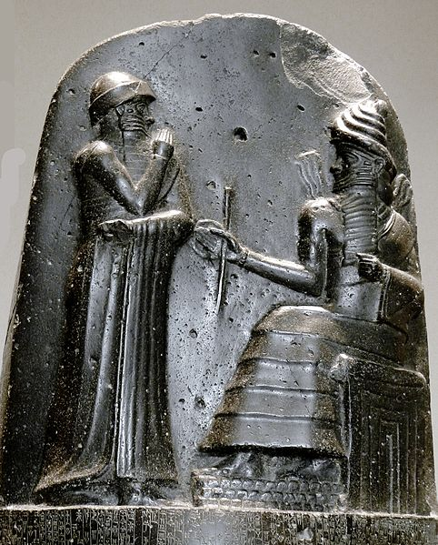  Carving on the top of a stele with the Code of Hammurabi inscribed below it.  P1050771 Louvre code Hammurabi bas relief rwk.JPG by Mbzt is published under the CC BY 3.0 Unported license
What enduring issue could this document be?

What is evidence to back this enduring issue up?

Give AT LEAST 2 examples of OUTSIDE INFORMATION that would go along with this document.

Document 2: The Ten Commandments (Christianity)
And God spoke all these words, saying,
(1) I am the LORD thy God[...]
(2) Thou shalt have no other gods before me. Thou shalt not make unto thee any graven [engraved] image, or any likeness of anything that is in heaven above, or that is in the earth beneath, or that is in the water under the earth. Thou shalt not bow down thyself to them, nor serve them[…]
(3) Thou shalt not take the name of the LORD thy God in vain[…]
(4) Remember the sabbath day, to keep it holy[....] in it thou shalt not do any work, thou, nor thy son, nor thy daughter, thy manservant, nor thy maidservant, nor thy cattle, nor thy stranger that is within thy gates[....]
(5) Honour thy father and thy mother: that thy days may be long upon the land which the LORD thy God giveth thee.
(6) Thou shalt not kill.
(7) Thou shalt not commit adultery [cheat on one’s husband or wife].
(8) Thou shalt not steal.
(9) Thou shalt not bear false witness [lie] against thy neighbor.
(10) Thou shalt not covet [want] thy neighbor’s house, thou shalt not covet thy neighbour's wife, nor his manservant, nor his maidservant, nor his ox, nor his ass [donkey], nor any thing that is thy neighbor’s[....]

What enduring issue could this document be?

What is evidence to back this enduring issue up?

Give AT LEAST 2 examples of OUTSIDE INFORMATION that would go along with this document.

Document 3: Millets in the Ottoman Empire
“In the Ottoman Empire, non-Muslims were not required to convert to Islam. Instead, the Ottoman Empire developed millets. Millets were self-governing non-Muslim (Jewish and Christian) communities within the Ottoman Empire that had the power to regulate their own communities, collect taxes, set up their own schools, and organize their own laws. The millets were run by a religious leader who was responsible for maintaining peace within the millet. In return for religious freedom, non-Muslims within the millets owed absolute loyalty to the Ottoman Empire. Additionally, non-Muslims were barred from high government positions in the Ottoman Empire.”
GO TO THE NEXT PAGE AND ANSWER THE QUESTIONS FOR THIS DOCUMENT PLEASE !
What enduring issue could this document be?

What is evidence to back this enduring issue up?

Give AT LEAST 2 examples of OUTSIDE INFORMATION that would go along with this document.

