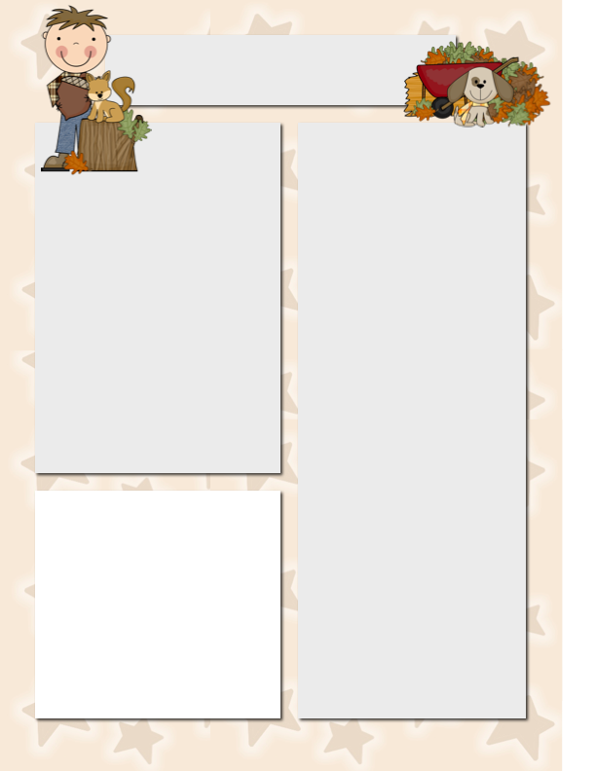

**This Week in ELA**

This week we continued to word build and added the ch and sh diagraphs. We began our first 1st Grade Reader titled ‘Scott.’ We have been reading the stories from this book and answering questions in our Skills Workbooks by finding the evidence in the story.

Miss B. has continued to read stories about Outer Space. We have read passages about Venus, Earth, Mars, and Jupiter. We have also been working on answering questions based on these non-fiction texts. The class is really enjoying this unit and is doing a terrific job of finding the evidence with their highlighters.

**This Week in Math**

In math this week we reviewed solving addition word problems using pictures. We also started using a number line to help us add.

**Dates to**

**Remember**

October 8 – Columbus Day

No School

October 9 – Superintendent’s Day

No School

October 11 – Fire Safety Assembly

October 24 – Bubble Trouble

Field Trip

October 31 – Halloween Parade

**Please Note**

Next week due to the shortened week there will not be a spelling test or homework. Please keep an eye out for other homework that will be coming home in your child’s Home/School Folder.

Mrs. Hunt installed the Math Seeds and Reading Eggs app on our classroom iPads. This is a free app to download on most devices at home. If you cannot find your child’s username/password let me know and I’ll send it home.

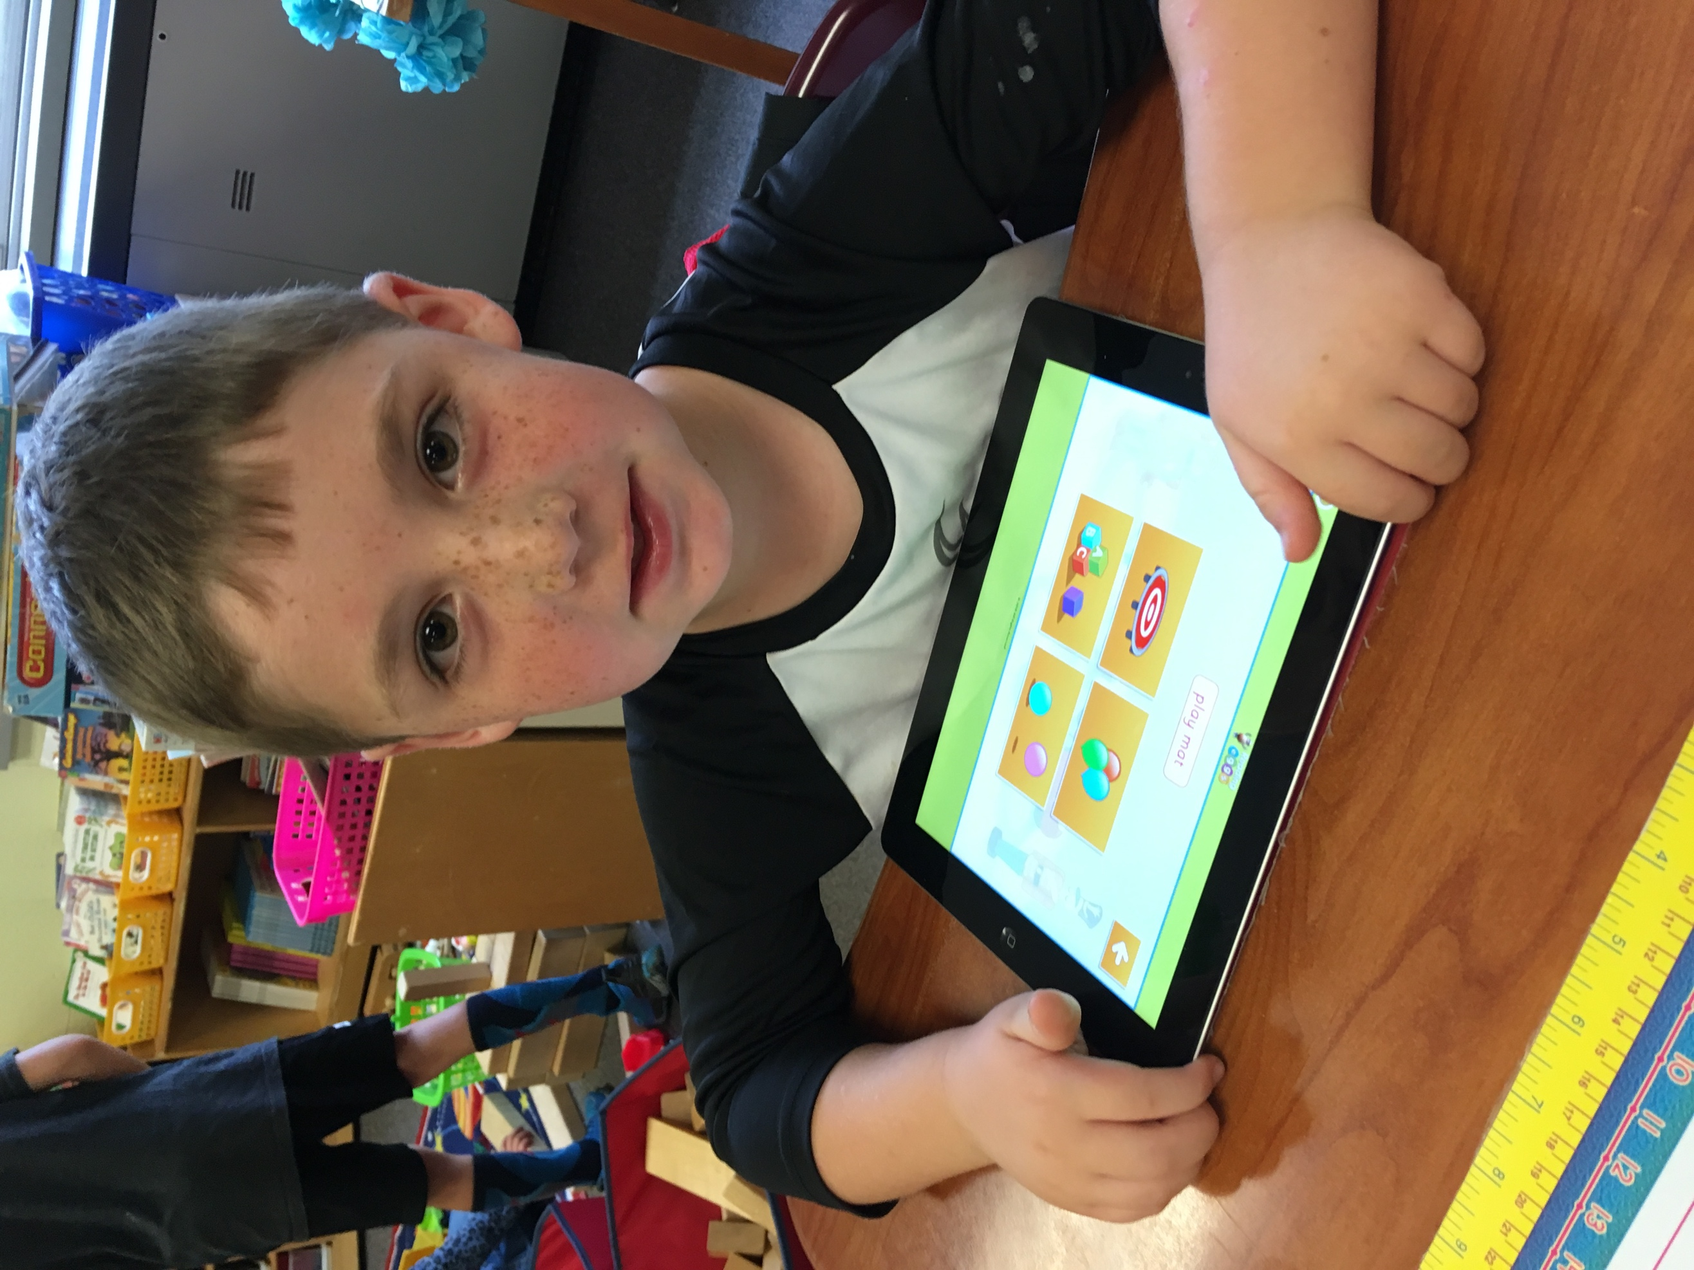

Mrs. Keller’s Classroom Newsletter

***October 5, 2018***