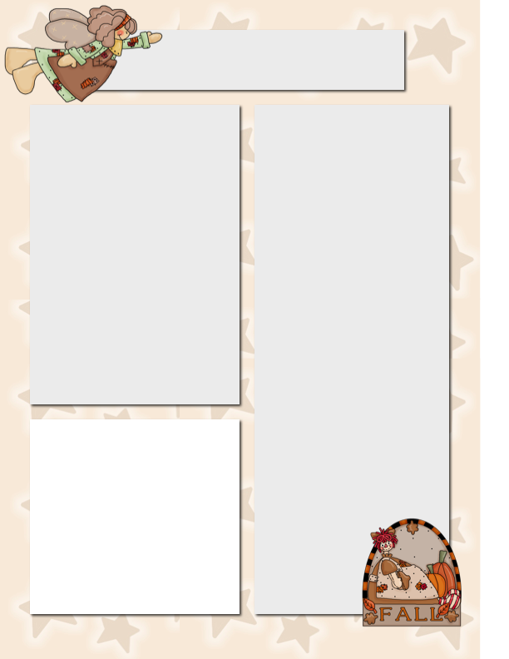

**This Week in ELA**

This week we added the ‘wh’ diagraph to our word building work. This has been great practice for us every day.

We read 2 new stories from our ‘Scott’ reader. Please find a safe place to keep your stories at home and find time to practice them for a few minutes each day.

In our Science unit about space we have now learned about all of the planets. Next week we will wrap up the unit with a Virtual Field trip to the BOCES Star Lab, which will be set up in the Elementary Gymnasium.

**This Week in Math**

We sent home some addition flash cards this week. Please keep these in a safe place and take 3-5 minutes each day to practice with your child. We will begin taking math fact tests over the next few weeks. I will be sending home

more flash cards

to add to your

bag as we

become ready

for them.

**Dates to Remember**

October 24 – Bubble Trouble

Field Trip

October 31 – Halloween Parade

November 7 – Picture Retakes

November 8 – Parent/Teacher

Conferences

½ Day of School

**Bubble Trouble**

On October 24th we will be taking a field trip to Salamanca High School to watch a ‘Bubble Trouble’ performance. If you have not returned your child’s permission slip please do so A.S.A.P.

Thursday, we attended a Fire Safety Assembly presented by firefighters from the Ellicottville, Great Valley, and Humphrey Fire Companies.

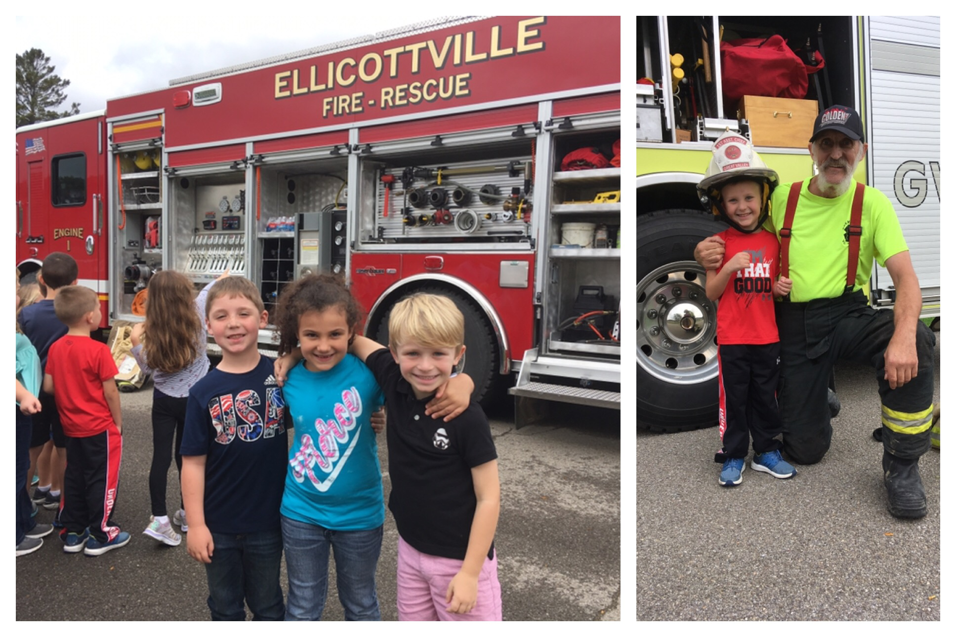

**Fire Safety Assembly**

Mrs. Keller’s Classroom Newsletter

October 12, 2018