**Directions**: Answer the following questions using the documents and your knowledge of Global history.

**Multiple Choice**: Circle the correct answer and mark it on your answer sheet.

Base your answer to the questions 1 & 2 on the diagram below and on your knowledge of social studies.

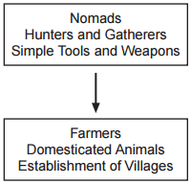

1. What is the best title for this diagram?
   1. Elements of Belief Systems
   2. Characteristics of Classical Civilizations
   3. Benefits of the Counter Reformation
   4. Changes during the Neolithic Revolution
2. Which of the following was an effect of the turning point identified in this diagram?
   1. Paleolithic gatherers gained more power
   2. Establishment of the first civilizations
   3. Food supplies became insecure
   4. Livestock became wild

**From Food Gathering To Food Producing**

|  |
| --- |
| . . . Paleolithic men could not control their food supply. So long as they relied on foraging, hunting, fishing, and trapping, they were dependent on the natural food supply in a given area to keep from starving. But while Paleolithic men continued their food-gathering pattern of existence in Europe, Africa, and Australia, groups of people in the Near East began to cultivate edible plants and to breed animals. Often described as the “first economic revolution” in the history of man, this momentous change from a food-gathering to a food-producing economy initiated the Neolithic Age. Paleolithic man was a hunter; Neolithic man became a farmer and herdsman. . . . |

1. Based on the passage above, identify one advantage of living the way “Neolithic man” lived.
   1. More leisure time
   2. More reliable food sources
   3. More travel
   4. Greater knowledge of wild plants

Using the document and your knowledge of Global 9, answer questions 4 & 5.

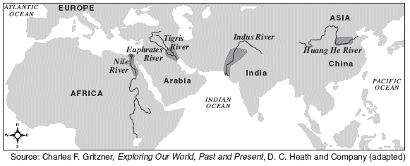

1. The main purpose of this map is to illustrate the location of
   1. overseas trade routes
   2. early belief systems
   3. river valley civilizations
   4. burial sites of ancient rulers
2. The historical development depicted in this map is an effect of
   1. The use of primary sources
   2. Judaism
   3. The Neolithic Revolution
   4. The Golden Age of Greece

Using the document and your knowledge of Global 9, answer questions 6 & 7.

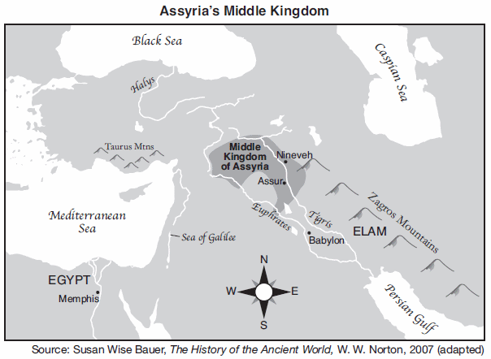

1. The Middle Kingdom of Assyria was located in an area also known as the
   1. Subcontinent
   2. Holy Land
   3. Fertile Crescent
   4. rooftop of the world
2. What is the primary reason why the Middle Kingdom of Assyria was established in this location?
   1. The location is northeast of Egypt
   2. The location is close to the Black Sea
   3. The location is close to the Zagros Mountains
   4. The location is between the Tigris and Euphrates Rivers

Using the document and your knowledge of Global 9, answer question 8.

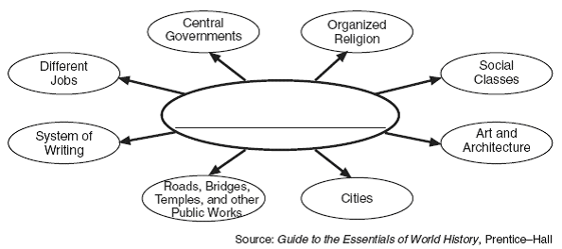

1. Which title best completes this diagram?
   1. Elements of a Civilization
   2. Features of a Nomadic Lifestyle
   3. Basic Components of the Paleolithic Age
   4. Human Life 50,000 Years Ago

Use the document and your knowledge of Global 9 to answer question 9.

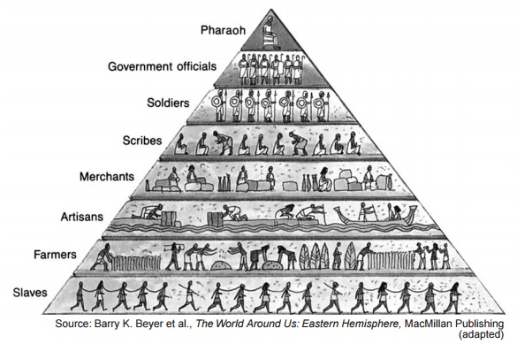

1. What Ancient civilization is this document most likely associated with?
   1. Rome
   2. Mesopotamia
   3. China
   4. Egypt

Use the document and your knowledge of Global 9 to answer questions 10 & 11.

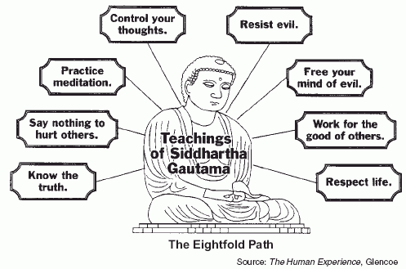

1. What statement is best supported by the information in the diagram?
   1. Buddhists support the use of violence when it is required.
   2. Buddhists believe in reincarnation.
   3. Buddhists support the caste system.
   4. Buddhists use meditation to practice controlling their thoughts.
2. Where did Buddhism originate?
   1. China
   2. Mesopotamia
   3. India
   4. Egypt

Base your answer to questions 12 & 13 on the diagram and on your knowledge of social studies.

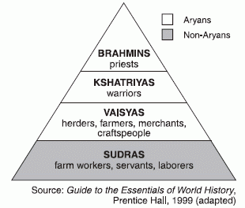

1. What statement is best supported by the information in the diagram?
   1. The Gupta Emperors did not support the caste system.
   2. Buddhists followed the caste system to provide order in their community
   3. The caste system enabled Hindus to choose where they lived.
   4. The caste system determined what occupations one could have.
2. Identify one effect the caste system had on Hindus during the Gupta Empire.
   1. Hindus followed their caste-duty to be reincarnated in a higher caste.
   2. Hindu missionaries were sent throughout Asia and the Middle East to spread the religion.
   3. Hindus followed Siddhartha Gautama's teaching to guide their lives
   4. Hindus believed that no matter what they did, they would be reborn in the same caste in the next life.

Use the document and your knowledge of Global 9 to answer questions 14 & 15.

|  |
| --- |
| **The Grand Canal of China**  ...The Grand Canal got more attention than other waterways because it was the main route to the capital city. Officials used it to travel to the court. Above all, its purpose was to carry grain from the south to the north. Taxes were paid in rice that was used to feed the court and pay the wages of workers and the army. At times when the canal was neglected, the grain had to be taken north by sea. But sailing ships were exposed to storms and pirates. Even when steamships plied the coast, the grain continued to be carried on the Grand Canal until 1901, for this provided jobs for many people…. |

1. Identify a claim supported by the excerpt above.
   1. The Grand Canal made little impact on China’s history
   2. The Grand Canal made trade between northern and southern China easier
   3. The 19th century Chinese dynasties did not use the Grand Canal
   4. Private activity increased off the coast of China as a result of the Grand Canal
2. Identify a generalization supported by evidence from the excerpt above.
   1. Increased economic activity can be used to collect more taxes and improve other aspects of a society
   2. Canals do not provide any benefit to the military
   3. People can do little to change their environment to better meet their needs
   4. Technology rarely changes

Base your answer to the question below on the illustration below and on your knowledge of social studies.

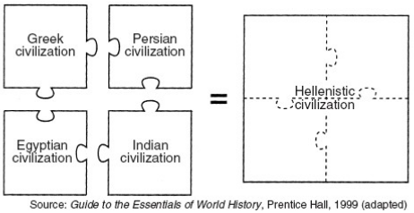

1. Which claim is supported by the illustration above?
   1. Persian and Greek civilization were isolated from one another
   2. Alexander the Great’s empire led to cultural diffusion between the civilizations he conquered
   3. Armed conflict between Indian and Egyptian civilizations led to the creation of Hellenistic civilization
   4. Greek, Persian, Egyptian, and Indian civilizations used Hellenistic irrigation to grow crops

Use the following document and your knowledge of Global 9 to answer questions 17 and 18.

1. Based on the document, Sparta was a part of what league?
   1. Delian League
   2. Major League
   3. Greek League
   4. Peloponnesian League
2. Why did Sparta and other Greek city-states split away from the Delian League?
   1. Athens was no longer in charge of the League
   2. Macedonia gained too much power in the League
   3. Sparta and other Greek city-states were upset with how Athens was leading the League
   4. Sparta did not want to lead the Delian League and thus broke away for economic reasons
3. Which statement most likely represents the view of a citizen of ancient Athens visiting Sparta?
4. “The government and society in Sparta are so strict. The people have little voice in government.”
5. “I feel as though I have never left home. Everything here is the same as it is in Athens.”
6. “This society allows for more freedom of expression than I have ever experienced in Athens.”
7. “I have never heard of a society like Sparta that believes in only one God.”

Use the following quote and your knowledge of Global 9 to answer the following question.

“An Athenian citizen does not put his private affairs before the affairs of the state… We alone believe that a man who takes no interest in the public affairs is more than harmless…he is useless…the power to make the laws is given to the many rather than a few.”

Pericles, 431 BC

1. Which type of political system does the quotation suggest the people of ancient Athens had?
   1. Monarchy
   2. Aristocracy
   3. Democracy
   4. Autocracy

Use the following document and your knowledge of Global 9 to answer questions 21 and 22.

1. Which statement is best supported by the information on this map?
   1. The Roman Empire extended over three continents
   2. Rivers kept invaders out of the Roman Empire.
   3. Alexandria served as the eastern capital of the Roman Empire
   4. Carthage was eventually destroyed by the Romans
2. Based on the information provided by this map, which body of water was most likely the center of Roman trade?
   1. Red Sea
   2. Black Sea
   3. Atlantic Ocean
   4. Mediterranean Sea

Use the following document and your knowledge of Global 9 to answer questions 23 and 24.

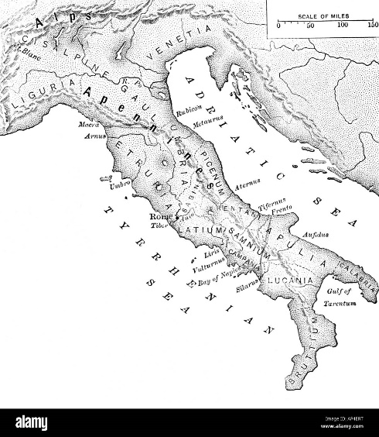

1. What ancient civilization began in area of the map shown above?
   1. Greece
   2. Egypt
   3. Gupta
   4. Rome

1. Based on the map, the Roman Empire was in between what two bodies of water?
   1. Nile and Euphrates River
   2. Artic and Atlantic Ocean
   3. Black and Arabian Sea
   4. Tyerhenian and Adriatic Seas

Use the following document and your knowledge of Global 9 to answer questions 25 and 26.



1. The following masks was a result of what outbreak in Eurasia?
   1. Smallpox
   2. Measles
   3. Black Plague
   4. Spanish Flu
2. What was **NOT** one major cause of the black plague?
   1. Trade declined
   2. Population declined
   3. Trust in the Church declined
   4. Feudalism flourished

Use the following document and your knowledge of Global 9 to answer question 27.

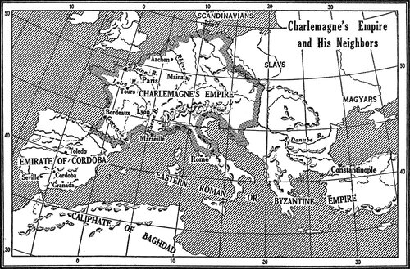

1. What is the effect of Charlemagne coming to power from 768-814?
   1. Germany continued to invade Rome
   2. Western Europe was unified
   3. The Roman Empire rose up again
   4. The Slavs planned invasions of his empire

Use the following document and your knowledge of Global 9 to answer questions 28 and 29.

|  |
| --- |
| “Feudalism was the natural response to the greatest political need of the Dark Ages: security. Since there was no central government capable of providing this security, men fell back on their own resources, making local arrangements. Already, in the last chaotic centuries of imperial rule, Roman magnates had supported, and had been supported by, groups of clients. Among the Germanic tribes beyond the imperial frontiers, a roughly similar system of armed personal retainers had existed. From these precedents and from sheer necessity, feudalism was created in the Carolingian state in the ninth and tenth centuries.” |

1. What led to the rise of Feudalism in Europe?
   1. The fall of the Roman Empire
   2. Persia losing to Greece in the Persian Wars
   3. Ferdinand and Isabella controlling Spain from the Muslim Turks
   4. Economic success in the middle ages
2. Who held the majority of the power in European Feudalism?
   1. Kings
   2. Lords (Nobles)
   3. Knights
   4. Peasants (Serfs)

Use the following document and your knowledge of Global 9 to answer question 30.

|  |
| --- |
| “In the horror thereof brother was forsaken by brother… and oftentimes husband by wife; nay, what is more, and scarcely to be believed, fathers and mothers were found to abandon their own children, untended, unvisited, to their fate, as they had been strangers,”—Boccaccio (Italian Poet) |

1. The following conclusion can be made about the quote “fathers and mothers were found to abandon their own children.”
   1. Traditional families were non-existent in Medieval Europe
   2. The Black Plague affected mostly children
   3. People left traditional values out of fear of the plague
   4. Children were not affected by the death tole of the plague

**CRQ’s**: For both CRQ’s, please answer the questions with complete sentences. Ensure that for the part three, you use both documents.

**Document 1**: Paleolithic Hunting

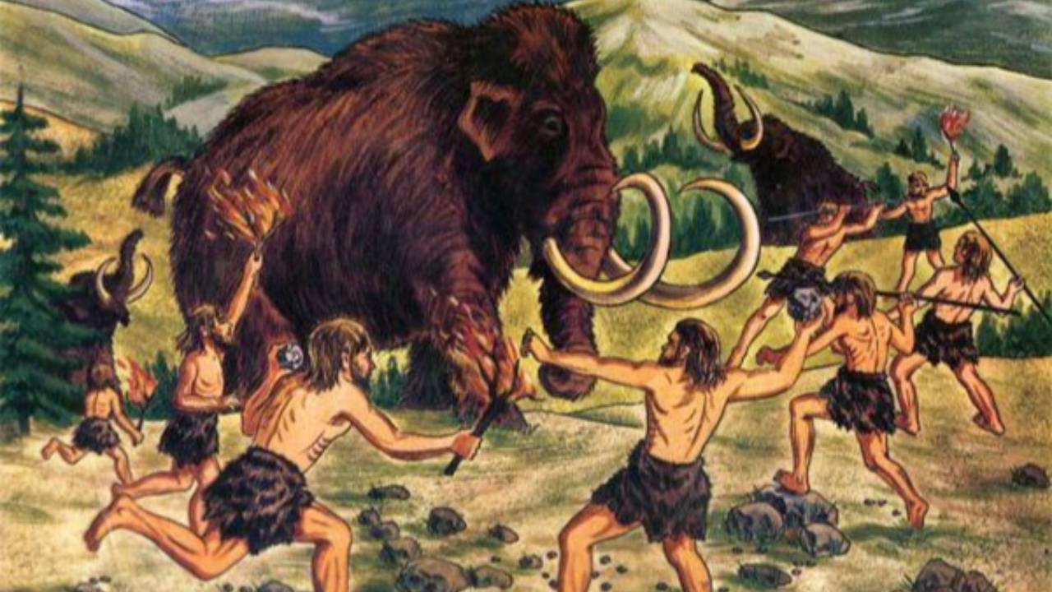

1. Describe the historical circumstances of the photo above.

**__________________________________________________________________________________________________________________________________________________________________________________________________________________________________________**

**Document 2**: Neolithic Revolution

|  |
| --- |
| The Neolithic Revolution, also called the Agricultural Revolution, marked the transition in human history from small, nomadic bands of hunter-gatherers to larger, agricultural settlements and early civilization. The Neolithic Revolution started around 10,000 B.C. in the Fertile Crescent, a boomerang-shaped region of the Middle East where humans first took up farming. Shortly after, Stone Age humans in other parts of the world also began to practice agriculture. Civilizations and cities grew out of the innovations of the Neolithic Revolution. |

1. Describe the purpose of farming in the switch from the Paleolithic to the Neolithic Revolution.

**__________________________________________________________________________________________________________________________________________________________________________________________________________________________________________**

Base your answer on **both Documents 1 and 2** and on your knowledge of Global 9.

Turing Point—is a major event, idea, or historical development that brings about significant change. It can be local, regional, national, or global.

1. Using evidence from both Documents 1 and 2 and your knowledge of Social Studies:
2. Identify a turning point associated with the historical developments related to both Documents **1 and 2**.
3. Explain why the historical developments associated with these documents are considered a turning point. Be sure to use evidence from both Documents 1 and 2 in your response.

**__________________________________________________________________________________________________________________________________________________________________________________________________________________________________________**

**Enduring Issue Essay**

An enduring issue is a challenge or problem that has been debated or discussed across time. An enduring issue is one that many societies have attempted to address with varying degrees of success.

**Task:**

* Identify and define an enduring issue raised by this set of documents
* Using your knowledge of social studies and evidence from the documents, argue why the issue you selected is significant and how it has endured across time
* In developing your answers to Part III, be sure to keep these explanations in mind:

**Guidelines:** **In your essay, be sure to**

* Identify the enduring issue based on a historically accurate interpretation of at least ***three*** documents.
* Define the issue using evidence from at least ***three*** documents
* Argue that this is a significant issue that has endured by showing:
  + How the issue has affected people or has been affected by people
  + How the issue has continued to be an issue or has changed over time
* Include outside information from your knowledge of social studies and include evidence from the documents

**ENDURING ISSUE ESSAY**

*Directions:* Read and analyze each of the five documents and write a well-organized essay that includes an introduction, several paragraphs, and a conclusion. Support your response with relevant facts, examples, and details based on your knowledge of social studies and evidence from the documents.

**Document 1**

|  |
| --- |
| **From Food Gathering To Food Producing** |
| . . . Paleolithic men could not control their food supply. So long as they relied on foraging, hunting, fishing, and trapping, they were dependent on the natural food supply in a given area to keep from starving. But while Paleolithic men continued their food-gathering pattern of existence in Europe, Africa, and Australia, groups of people in the Near East began to cultivate edible plants and to breed animals. Often described as the “first economic revolution” in the history of man, this momentous change from a food-gathering to a food-producing economy initiated the Neolithic Age. Paleolithic man was a hunter; Neolithic man became a farmer and herdsman. . . . |
| Source: T. Walter Wallbank, et al., Civilization: Past and Present, Scott, Foresman and Company from the January, 2010 NYS Global History and Geography Regents Examination. |

**Document 2**

|  |  |
| --- | --- |
| **Terrace Farming**  Several societies including the Chinese used terrace farming to create farmland where there is little to grow food for growing populations. The technique involves cutting land away from a hillside to create flat surfaces that look like large steps. Plants can then be grown on the newly flattened sections. | |
| https://lh7-us.googleusercontent.com/8_WkswKLDk_cLAb94HOcfvzER20ALsnuGtu4fCu3ORjSxBoQyHM2f1--99bBc-EfHRSxAb1LhC2fZgIrefDLTLSh7CziFS5VUyQKYkWcu3ziCqZl4LRy-DGO6Y9TYrTv1TnEnVIeNf3-wSI1QTWfZA  Rice terraces  Source: [Rice terraces.png](https://commons.wikimedia.org/wiki/File:Rice_terraces.png) by McCouch S published under the [Creative Commons](https://en.wikipedia.org/wiki/en:Creative_Commons) [Attribution 2.5 Generic](https://creativecommons.org/licenses/by/2.5/deed.en) license. | Terrace farming technique |

**Document 3**

|  |
| --- |
|  |
| The first successful efforts to control the flow of water were made in Mesopotamia and Egypt, where the remains of the prehistoric irrigation works still exist. In ancient Egypt, the construction of canals was a major endeavor of the pharaohs and their servants, beginning in Scorpio’s time. One of the first duties of provincial governors was the digging and repair of canals, which were used to flood large tracts of land while the Nile was flowing high. The land was checkerboarded with small basins, defined by a system of dikes [dams]. Problems regarding the uncertainty of the flow of the Nile were recognized. During very high flows, the dikes were washed away and villages flooded, drowning thousands. During low flows, the land did not receive water, and no crops could grow. In many places where fields were too high to receive water from the canals, water was drawn from the canals or the Nile directly by a swape or a shaduf. These consisted of a bucket on the end of a cord that hung from the long end of a pivoted boom, counterweighted at the short end. The building of canals continued in Egypt throughout the centuries.…  **Screen Shot 2017-05-17 at 3.41.53 PM.png**  This frieze, or architectural adornment, on an ancient temple portrays Egyptians using *shadufs*, devices that enabled them to transfer water from the Nile to their fields. |
| **Source:** Larry W. Mays, “Irrigation Systems, Ancient,” Water Encyclopedia online (adapted) from the NYS Global History and Geography Regents Exam, January 2014; James Barter, The Nile, Lucent Books from the NYS Global History and Geography Regents Exam, January 2014. |