**Ellicottville Central School Health Office**

**PARENT INSTRUCTION SHEET FOR HEAD LICE**

**To Parents**: If your child comes home with head lice, don’t panic. Millions of school children contract head lice each year. Children play in close contact with each other. A simple exchange of hats, clothing, brushes, combs, and other personal articles can result in transmission of head lice from one child to another. Lice can be easily and effectively treated. You

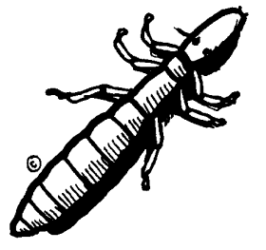

should ask your pharmacist for an effective head lice shampoo or ask your doctor for advice.

* Please send the box top from the head lice shampoo

back to school with your child as proof of treatment, along with a short note describing the treatment.

* Check all members of the family for lice and their eggs. Lice are small grayish-tan wingless insects. Lice lay eggs called nits.
* Nits are firmly attached to the hair shafts, close to the scalp and are much easier to see than live lice. They are small white specks which are usually found at the nape of the neck and behind the ears.
* Apply the lice treatment to all infested family members, following instructions carefully.
* After shampooing, remove the nits with a fine tooth comb (nib combs come with some head lice shampoos). Application of warm water with vinegar (1:1) or clear warm water may help nit removal. Nits may need to be removed by using your fingernails or tweezers.
* Use hot water and detergent to wash sheets, pillowcases and clothing (at least 20 minutes).
* Hot dry or dry clean blankets, bedspreads, hats, and sleeping bags; or seal in a plastic trash bag for at least two weeks.
* Soak combs and brushes, head bands and barrettes in the treatment shampoo or hot water for at least 10 minutes or wash in dishwasher.
* Thoroughly vacuum carpets, upholstery, pillows, and mattresses and discard vacuum cleaner bag.
* Bike helmets, head phones, stuffed animals should be placed in a plastic bag and tied for 10 days.
* Remember to retreat in 7 days.

Please call the school’s Health Office if you have any questions or concerns.

Karin Hager, RN, School Nurse Ellicottville Central School (716)699-2318 x 604