**Directions**: Answer the following questions using the documents and your knowledge of Global history.

**Multiple Choice**: Circle the correct answer and mark it on your answer sheet.

Use the following document and your knowledge of Global 10 to answer questions 1 & 2.

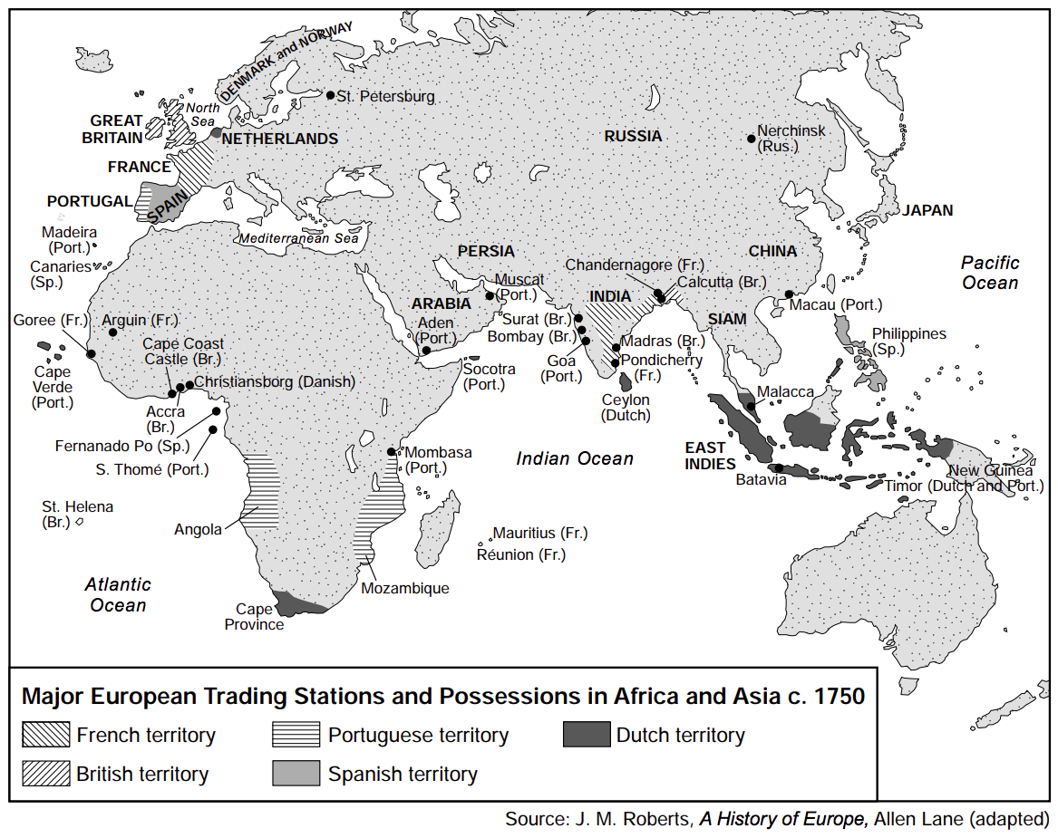

1. What is a valid conclusion based on the information shown on this map?
   1. Russia had the largest number of trading stations in Asia
   2. Most European trading stations and empires were located along the coast
   3. France controlled more ports in India than Britain did
   4. Each European power represented had possessions in the East Indies
2. Which Europeans controlled the waterways connecting the Indian Ocean to the Pacific Ocean?
   1. Spanish
   2. Portuguese
   3. Dutch
   4. French

Use the following document and your knowledge of Global 10 to answer questions 3 & 4.

|  |
| --- |
| In the very heart of Tokyo sits the imperial palace, site of the former Edo Castle. Inside a colossal moat with ramparts that dwarf anything seen in Europe, vast open spaces enclose the last fragments of one of the world’s most imposing seventeenth-century monuments. Across the globe in France, Louis XIV’s palace and gardens of Versailles form a similar impression of artificial mastery of nature and society. Miles of formal gardens punctuated [decorated] with fountains and statuary surround a palace known for its cold magnificence, with the entire ensemble of town, palace, and park orienting itself around a single, central focal point: the Sun King’s bedroom. Each complex symbolizes a system of power. Edo evokes [brings to mind] the Tokugawa rule by status, which decreed that the daimyo lords, who were themselves forced to spend alternate years in Edo away from their regional domains, lived administratively and spatially segregated from the various other categories of subjects, all ranged in a pattern of residential sectors spiraling around the castle. Versailles, in similar fashion, bespeaks [indicates] the domestication of the French aristocracy in a “gilded cage,” where they scrambled for favors while the Sun King undermined their authority and deprived them of their independence... |

1. Based on this passage, one way the castle at Edo and the palace at Versailles are similar is that both
   1. became symbols of power and wealth
   2. developed into monastic centers of learning
   3. were meant to provide protection and prevent attacks
   4. served as monuments to the military
2. Which claim can best be supported by this passage?
   1. The more independent the nobles were the higher their status.
   2. Nobles maintained their authority by remaining isolated.
   3. Rulers controlled their nobles by influencing where they lived.
   4. Spending time in segregated sectors guaranteed nobles the support of their ruler.

Use the following document and your knowledge of Global 10 to answer question 5.

|  |
| --- |
| Edict of 1635 Ordering the Closing of Japan  • Japanese ships are strictly forbidden to leave for foreign countries.  • No Japanese is permitted to go abroad. If there is anyone who attempts to do so secretly, he must be executed. The ship so involved must be impounded and its owner arrested, and the matter must be reported to the higher authority.  • If any Japanese returns from overseas after residing there, he must be put to death. . . .  • Any informer revealing the whereabouts of the followers of padres (Christians) must be rewarded accordingly. If anyone reveals the whereabouts of a high ranking padre, he must be given one hundred pieces of silver. For those of lower ranks, depending on the deed, the reward must be set accordingly. . . . |

1. These rules reflect the Japanese policy of
   1. totalitarianism
   2. appeasement
   3. interdependence
   4. isolationism

Use the following document and your knowledge of Global 10 to answer questions 6 & 7.

|  |
| --- |
| … Nor is there liberty if the power of judging is not separate from legislative power and from executive power. If it were joined to legislative power, the power over the life and liberty of the citizens would be arbitrary, for the judge would be the legislator. If it were joined to executive power, the judge could have the force of an oppressor.…                           —Montesquieu, The Spirit of the Laws |

1. In this passage, Montesquieu references
   1. enlightened despotism
   2. a policy of mercantilism
   3. a separation of powers
   4. a social contract
2. Which group’s ideas are best supported by this excerpt
   1. Enlightened philosophers
   2. Absolute Monarchs
   3. Communists
   4. Missionaries

Use the following document and your knowledge of Global 10 to answer questions 8 & 9.

|  |
| --- |
| “If man in the state of nature is free, if he is absolute lord of his own person and possessions, why will he give up his freedom? Why will he put himself under the control of any person or institution? The obvious answer is that rights in the state of nature are constantly exposed to the attack of others. Since every man is equal and since most men do not concern themselves with equity and justice, the enjoyment of rights in the state of nature is unsafe and insecure. Hence each man joins in society with others to preserve his life, liberty, and property.”  — John Locke, Two Treatises of Government, 1690 |

1. This statement provides support for the
   1. elimination of laissez-faire capitalism
   2. formation of government based on a social contract
   3. continuation of absolute monarchy
   4. rejection of the natural rights philosophy
2. Which of these events was most heavily influenced by the ideas in this passage?
   1. Industrial Revolution
   2. Napoleon's conquest of Rome
   3. Russian Revolution
   4. Latin American Revolutions

Use the following document and your knowledge of Global 10 to answer question 10.

|  |
| --- |
| … We must ask ourselves three questions.  1. What is the Third Estate? Everything.  2. What has it been until now in the political order? Nothing.  3. What does it want to be? Something. … |

1. Based on this passage, what did the Third Estate want?
   1. independence from France
   2. more influence in the political system
   3. removal of the monarchy
   4. freedom of religion in France

Use the following document and your knowledge of Global 10 to answer questions 11 & 12.

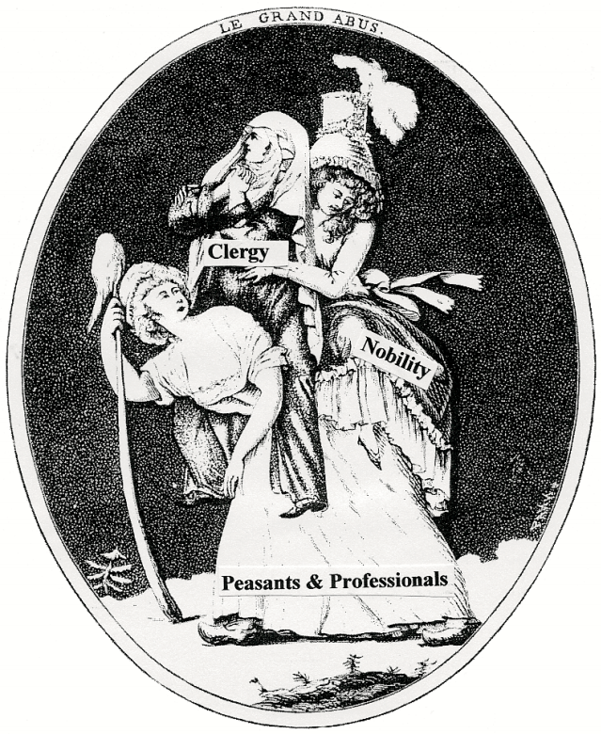

1. This drawing illustrates conditions that contributed primarily to the beginning of the
   1. Protestant Reformation
   2. French Revolution
   3. Napoleonic Wars
   4. European Renaissance
2. What is the point of view of the author of this drawing?
   1. One group paid heavy taxes that supported the other two groups.
   2. Hard work, prayer, and a good example allowed for a stable government in France.
   3. Peasants and professionals in this society were gaining political and economic power.
   4. French society emphasized the importance of natural law and social equality.

Use the following document and your knowledge of Global 10 to answer question 13.

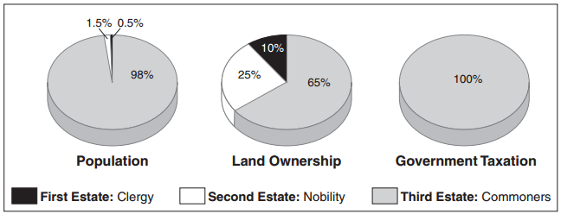

1. Based on the information in these graphs, identify one cause of the French Revolution.
   1. Over-taxation of the third estate
   2. Limited land ownership by the first estate
   3. Population decline amongst the second estate
   4. Population growth amongst the third estate

Use the following document and your knowledge of Global 10 to answer questions 14 & 15.

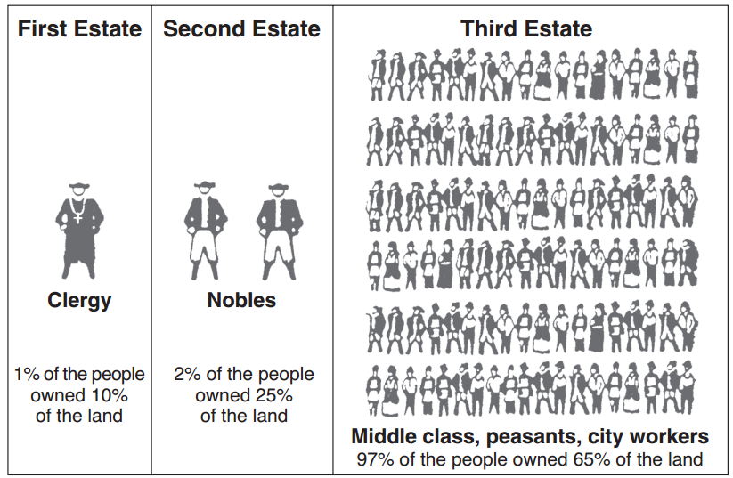

1. Which revolution resulted from the division of society shown in this diagram?
   1. Puritan (1642)
   2. French (1789)
   3. Mexican (1910)
   4. Russian (1917)
2. Which of the following resulted from the situation depicted in the diagram?
   1. Assassination of Archduke Franz Ferdinand
   2. Salt March
   3. Berlin Conference
   4. Storming of the Bastille

Use the following document and your knowledge of Global 10 to answer questions 16 & 17.

|  |
| --- |
| Declaration of the Rights of Man and the Citizen—1789  Approved by the National Assembly of France, August 26, 1789  Articles:  1. Men are born and remain free and equal in rights. Social distinctions may be founded only upon the general good.  2. The aim of all political association is the preservation of the natural and imprescriptible [inalienable] rights of man. These rights are liberty, property, security, and resistance to oppression. . . .  4. Liberty consists in the freedom to do everything which injures no one else; hence the exercise of the natural rights of each man has no limits except those which assure to the other members of the society the enjoyment of the same rights. These limits can only be determined by law. . . . |

1. Which of the following individuals most strongly influenced the ideas in the excerpt of the Declaration of the Rights of Man and the Citizen above?
   1. Louis XIV
   2. Montesquieu
   3. John Locke
   4. Thomas Hobbes
2. Which of the following states the point of view of the authors of the Declaration of the Rights of Man and the Citizen?
   1. A government should make laws to protect the natural rights of its citizen.
   2. Absolute monarchy is a form of government that guarantees the rights of citizens.
   3. Property is a more valuable natural right than security.
   4. A government should limit people's freedom to ensure they are safe.

Use the following document and your knowledge of Global 10 to answer questions 18 & 19.

|  |
| --- |
| . . . I shall tell you with what we must provide ourselves in order to expel the Spaniards and to found a free government. It is union, obviously; but such union will come about through sensible planning and well-directed actions rather than by divine magic. America stands together because it is abandoned by all other nations. It is isolated in the center of the world. It has no diplomatic relations, nor does it receive any military assistance; instead, America is attacked by Spain, which has more military supplies than any we can possibly acquire through furtive [stealthy] means.  When success is not assured, when the state is weak, and when results are distantly seen, all men hesitate; opinion is divided, passions rage, and the enemy fans these passions in order to win an easy victory because of them. As soon as we are strong and under the guidance of a liberal nation which will lend us her protection, we will achieve accord [unity] in cultivating the virtues and talents that lead to glory. Then will we march majestically toward that great prosperity for which South America is destined. Then will those sciences and arts which, born in the East, have enlightened Europe, wing their way to a free Colombia, which will cordially bid them welcome. . . .  -Simon Bolivar |

1. In this letter, Simón Bolívar’s goal is to
   1. become monarch of the strongest country in South America
   2. break off diplomatic relations with Europe
   3. form one nation that unifies all of South America
   4. convince Mexico to join in his fight against Spain
2. Simón Bolívar’s actions were most likely influenced by the ideas of
   1. church officials
   2. Enlightenment thinkers
   3. laissez-faire economists
   4. Marxist followers

Use the following document and your knowledge of Global 10 to answer questions 20 & 21.

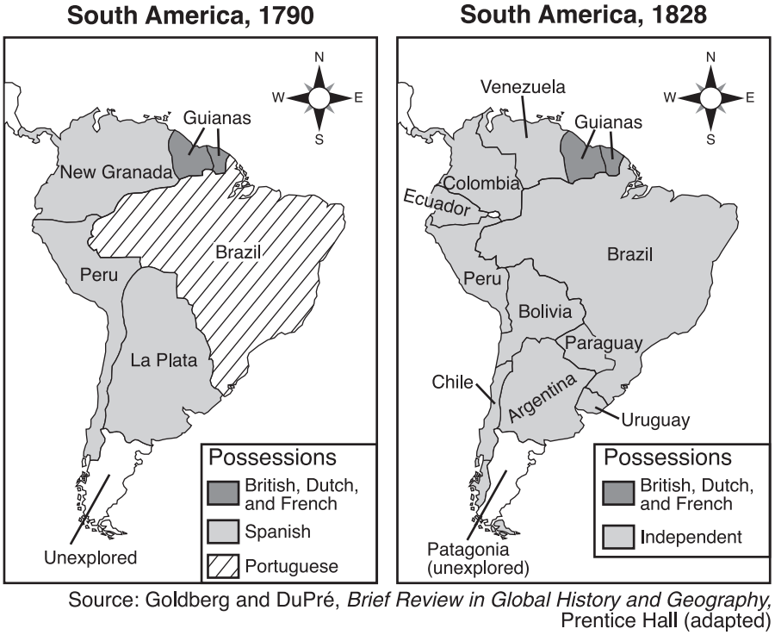

1. Based on a comparison of these maps of South America, which conclusion is accurate?
   1. Many regions of South America gained their independence between 1790 and 1828.
   2. All of South America was independent by 1828.
   3. Spain continued to gain South American colonies in the 19th century.
   4. Between 1790 and 1828, South American political boundaries remained unchanged except for Brazil
2. Which individual is most closely associated with the changes indicated on these maps?
   1. Emiliano Zapata
   2. Simón Bolívar
   3. Porfirio Díaz
   4. Pancho Villa

Use the following document and your knowledge of Global 10 to answer questions 22 & 23.

|  |
| --- |
| August 29, 1793  Brothers and friends.  I am Toussaint L’Ouverture, my name is perhaps known to you. I have undertaken vengeance. I want Liberty and Equality to reign in San Domingo. I work to bring them into existence. Unite yourselves to us, brothers, and fight with us for the same cause, etc. . . . |

1. Which statement describes the author’s purpose for writing this letter?
   1. To propose peace terms to the French
   2. To inspire a rebellion
   3. To document his thoughts for personal reflection
   4. To gather support for the French
2. Identify one effect of Toussaint L’Ouverture’s letter.
   1. The establishment of the independent nation of Haiti
   2. Independence from Spain
   3. Simon Bolivar was made president of the country
   4. San Domino became the most profitable French colony

Use the following document and your knowledge of Global 10 to answer questions 24 & 25.

|  |
| --- |
| “Not by democracy or liberal standards will our goal be achieved but by blood and iron. Then we will be successful, no nation is born without the traumatic experience of war.”  —Otto von Bismarck |

1. This statement was used to justify a policy of
   1. ethnocentrism
   2. militarism
   3. containment
   4. appeasement
2. This statement is most closely associated with German
   1. Nationalism
   2. Democracy
   3. Isolationism
   4. Christianity

Use the following document and your knowledge of Global 10 to answer question 26.

|  |
| --- |
| . . . For a century and a half, from 1688 to 1832, the British government was substantially in the hands of [well-to-do] landowners—the “squirearchy” or “gentlemen of England.” The result was a thorough transformation of farming, an Agricultural Revolution without which the Industrial Revolution could not have occurred.  Many landowners, seeking to increase their money incomes, began experimenting with improved methods of cultivation and stock raising. They made more use of fertilizers (mainly animal manure); they introduced new implements (such as the drill seeder and horse-hoe); they brought in new crops, such as turnips, and a more scientific system of crop rotation; they attempted to breed larger sheep and fatter cattle. An improving landlord, to introduce such changes successfully, needed full control over his land. He saw a mere barrier to progress in the old village system of open fields, common lands, and semi collective methods of cultivation. Improvement also required an investment of capital, which was impossible so long as the soil was tilled by numerous poor and custom-bound small farmers. . . . |

1. Identify one effect of the actions taken by wealthy landowners described in the passage.
   1. Decrease in the amount of food produced on farms in England
   2. Enclosure Acts and consolidation of small farms into large ones owned by a few farmers
   3. Wealthy landowners lost the money they invested in farming innovations
   4. Small farmers gained power in Parliament

Use the following document and your knowledge of Global 10 to answer questions 27 & 28.

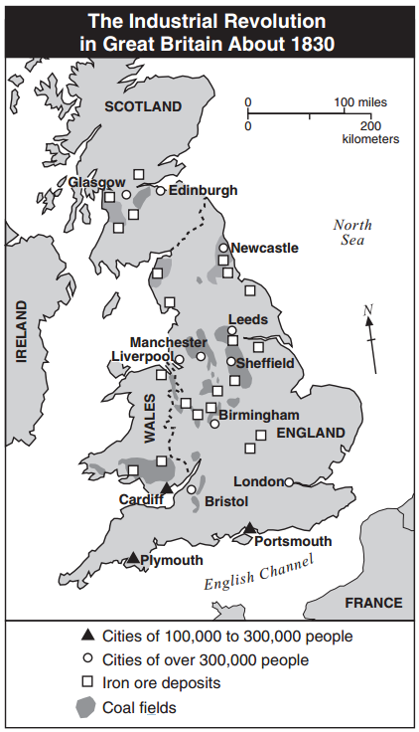

1. Which conclusion is best supported by the information on the map?
   1. England’s natural resources led to the growth of industrial cities.
   2. In 1830, England had an unfavorable balance of trade.
   3. Great Britain’s prosperity unified the people.
   4. People emigrated from Great Britain because of pollution.
2. Identify one effect of the historical development depicted in the map.
   1. The Glorious Revolution
   2. Overcrowded and polluted cities
   3. Higher employment for farmers
   4. England invaded France

Use the following document and your knowledge of Global 10 to answer question 29.

|  |
| --- |
| The Wealth of Nations carries the important message of laissez faire, which means that the government should intervene as little as possible in economic affairs and leave the market to its own devices. It advocates the liberation of economic production from all limiting regulation in order to benefit the people . . . |

1. According to Martin Perry, what role did Adam Smith believe the government should play in the economy?
   1. The government should regulate businesses to make sure they use safe practices.
   2. The government should restrict which businesses are allowed to open.
   3. The government should make very few laws that affect businesses.
   4. The government should play a role in helping businesses make as much money as possible.

Use the following document and your knowledge of Global 10 to answer questions 30-32.

|  |  |  |  |
| --- | --- | --- | --- |
| https://lh7-us.googleusercontent.com/tp7laWD4QzWhde8kagRJUGCUVuMVGsN2E4bitX52Egu8TiLFkL_pdg9Mszeq3RxXkxrsLMdcUcocJVcm_DYkWUP--hiZw2-X2zoo5W07EhA1jhHNpOKKofgJzTaV-cMP6uPq4ke0JgvvFRF07FEmNg  Source: George Pinwell, “Death’s Dispensary,” Fun Magazine, August 18, 1866 (adapted) | |  | | --- | | In cities and towns, drinking water was drawn from the same rivers into which raw sewage flowed. This sewage contaminated the water with the bacteria that cause cholera and typhoid fever. However, a direct link between germs and diseases had yet to be made. In England, London’s Thames river was so polluted that in the summer of 1858, the “Great Stink” drove Members of Parliament out of the House of Commons, situated close to the river. | | Source: Richard Walker, Epidemics & Plagues, Kingfisher, 2006 | |

1. This illustration and excerpt depict events from which time and place in history?
   1. Revolutionary France
   2. Victorian England
   3. Meiji Japan
   4. Soviet Russia
2. Which characteristic of the Industrial Revolution most directly contributed to the health concern highlighted in this illustration and excerpt?
   1. urban population growth
   2. improved communication
   3. new power sources
   4. trade union movement
3. Which action effectively addressed the specific public health concern raised in this illustration and excerpt?
   1. installation of electric lighting in poor neighborhood
   2. burning herbs to purify the air
   3. improvements in water treatment
   4. relocation of government offices

Use the following document and your knowledge of Global 10 to answer questions 33 & 34.

|  |
| --- |
| “It was a town of red brick, or of brick that would have been red if the smoke and ashes had allowed it; but as matters stood it was a town of unnatural red and black like the painted face of a savage. It was a town of machinery and tall chimneys, out of which interminable serpents of smoke trailed themselves for ever and ever, and never got uncoiled. It had a black canal in it, and a river that ran purple with ill smelling dye. . . .”  — Charles Dickens, Hard Times |

1. The author of this passage is describing conditions caused by the
   1. Commercial Revolution
   2. French Revolution
   3. Industrial Revolution
   4. Scientific Revolution
2. Which innovation most directly contributed to the conditions described in the passage?
   1. Printing press
   2. Crop rotation
   3. Seed drill
   4. Steam engine

Use the following document and your knowledge of Global 10 to answer question 35.

Speaker I: Government should not interfere in relations between workers and business owners.

Speaker II: The workers will rise up and overthrow the privileged class.

Speaker III: Private property will cease to exist. The people will own the means of production.

Speaker IV: A favorable balance of trade should be maintained by the use of tariffs.

1. Which two speakers represent Karl Marx’s ideas of communism?
   1. I and II
   2. II and III
   3. II and IV
   4. III and IV

**CRQ’s**: For both CRQ’s, please answer the questions with complete sentences. Ensure that for the part three, you use both documents.

**CRQ 1**: French Revolution

**Document 1**:

|  |
| --- |
| “. . . **Powers of the king**.—The King, Louis XVI, was absolute. He ruled by the divine right theory which held that he had received his power to govern from God and was therefore responsible to God alone. He appointed all civil officials and military officers. He made and enforced the laws. He could declare war and make peace. He levied taxes and spent the people’s money as he saw fit. He controlled the expression of thought by a strict censorship of speech and press. By means of lettres de cachet (sealed letters which were really blank warrants for arrest) he could arbitrarily imprison anyone without trial for an indefinite period. He lived in his magnificent palace at Versailles, completely oblivious to the rising tide of popular discontent. . . .” |

1. Explain the historical circumstances that led to Louis XVI consolidation of power.

**________________________________________________________________________________________________________________________________________________________________________________________________________________________________________________________________________________________________________________________**

**Please go to the next page 😊**

**Document 2**:

The etching below was created soon after the execution of King Louis XVI of France. The text has been translated and enlarged.

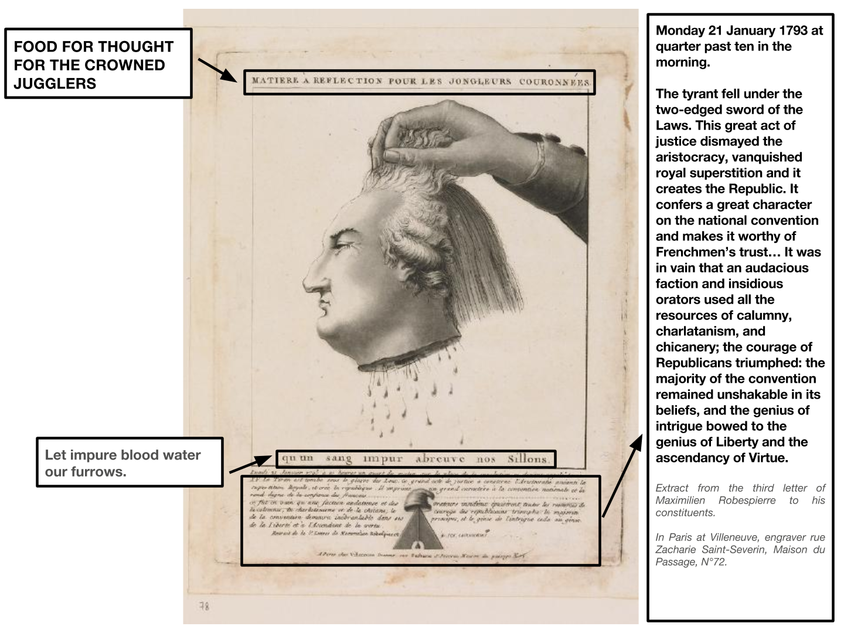

1. Using document 2, explain the purpose of the artwork.

**________________________________________________________________________________________________________________________________________________________________________________________________________________________________________________________________________________________________________________________**

Use **both Documents 1 and 2** and your knowledge of Global 10 to answer question 3.

Cause—refers to something that contributes to the occurrence of an event, the rise of an idea, or the bringing of a development.

Effect—refers to what happens as a consequence (result, impact, outcome) of an event, an idea, or a development.

1. Identify and explain a **cause-and-effect** relationship between the events and/or ideas found in these documents. **Be sure to use evidence from both Documents 1 and 2 in your response**.

**________________________________________________________________________________________________________________________________________________________________________________________________________________________________________________________________________________________________________________________**

**CRQ 2**: Industrial Revolution

**Document 1**: The excerpt of the letter below was written by the Cloth Merchants of Leeds, England in 1791. The letter was published in two local newspapers.

|  |
| --- |
| “In the Manufacture of Woollens, the Scribbling Mill, the Spinning Frame, and the Fly Shuttle, have reduced manual Labour nearly One third, and each of them at its – first Introduction carried an Alarm to the Work People, yet each has contributed to advance the Wages and to increase the Trade, so that if an Attempt was now made to deprive us of the Use of them, there is no Doubt, but every Person engaged in the Business, would exert himself to defend them.  From these Premises, we the undersigned Merchants, think it a Duty we owe to ourselves, to the Town of Leeds, and to the Nation at large, to declare that we will protect and support the free Use of the proposed Improvements in Cloth-Dressing, by every legal Means in our Power; and if after all, contrary to our Expectations, the Introduction of Machinery should for a Time occasion a Scarcity of Work in the Cloth Dressing Trade, we have unanimously agreed to give a Preference to such Workmen as are now settled Inhabitants of this Parish, and who give no Opposition to the present Scheme.” |

1. Explain the historical circumstances that led to the use of machines described in the letter.

**________________________________________________________________________________________________________________________________________________________________________________________________________________________________________________________________________________________________________________________**

**Document 2**: The petition below was written by the Leeds Woollen Workers. It was published in a local newspaper in 1786.

|  |
| --- |
| “...The number of Scribbling-Machines extending about seventeen miles south-west of LEEDS, exceed all belief, being no less than *one hundred and seventy!* and as each machine will do as much work in twelve hours, as ten men can in that time do by hand, (speaking within bounds) and they working night-and day, one machine will do as much work in one day as would otherwise employ twenty men....twelve men are thrown out of employ for every single machine used in scribbling…[as a result] eight thousand hands are deprived of the opportunity of getting a livelihood.  We therefore hope, that the feelings of humanity will lead those who l, have it in their power to prevent the use of those machines, to give every discouragement they can to what has a tendency so prejudicial to their fellow-creatures...  Men of common sense must know, that so many machines in use, take the work from the hands employed in Scribbling, - and who did that business before machines were invented...  ...How are those men, thus thrown out of employ to provide for their families; - and what are they to put their children apprentice to, that the rising generation may have something to keep them at work, in order that they may not be like vagabonds strolling about in idleness? Some say, Begin and learn some other business. - Suppose we do; who will maintain our families, whilst we undertake the arduous task [?]  But what are our children to do; are they to be brought up in idleness? Indeed as things are, it is no wonder to hear of so many executions;...bringing children up to industry, and keeping them employed, is the way to keep them from falling into those crimes, which an idle habit naturally leads to.” |

1. Using document 2, explain how audience affects the way the Leeds Wollen Workers presents their ideas.

**________________________________________________________________________________________________________________________________________________________________________________________________________________________________________________________________________________________________________________________**

Base your answer to question 41 on **both Documents 1 and 2** and on your knowledge of Global 10.

Similarity—tells how something is alike or the same as something else.

Difference—tells how something is not alike or not the same as something else.

1. Using evidence from both Documents 1 and 2 and your knowledge of social studies:
2. **Identify** a similarity **OR** a difference between documents 1 and 2.
3. **Explain** the similarity **OR** difference you identified using evidence from both documents.

**________________________________________________________________________________________________________________________________________________________________________________________________________________________________________________________________________________________________________________________**

**Enduring Issue Essay**

An enduring issue is a challenge or problem that has been debated or discussed across time. An enduring issue is one that many societies have attempted to address with varying degrees of success.

**Task:**

* Identify and define an enduring issue raised by this set of documents
* Using your knowledge of social studies and evidence from the documents, argue why the issue you selected is significant and how it has endured across time
* In developing your answers to Part III, be sure to keep these explanations in mind:

**Guidelines:** **In your essay, be sure to**

* Identify the enduring issue based on a historically accurate interpretation of at least ***three*** documents.
* Define the issue using evidence from at least ***three*** documents
* Argue that this is a significant issue that has endured by showing:
  + How the issue has affected people or has been affected by people
  + How the issue has continued to be an issue or has changed over time
* Include outside information from your knowledge of social studies and include evidence from the documents

**ENDURING ISSUE ESSAY**

*Directions:* Read and analyze each of the five documents and write a well-organized essay that includes an introduction, several paragraphs, and a conclusion. Support your response with relevant facts, examples, and details based on your knowledge of social studies and evidence from the documents.

**Document 1**

|  |  |  |  |  |  |  |  |  |  |  |  |  |  |  |  |  |  |  |  |  |  |
| --- | --- | --- | --- | --- | --- | --- | --- | --- | --- | --- | --- | --- | --- | --- | --- | --- | --- | --- | --- | --- | --- |
| **Jethro Tull’s Seed Drill** Components of Jethro Tull’s Seed Drill.  Jethro Tull Invented his horse-drawn seed drill in 1701. The machine drilled holes for three rows of seed at a time to the correct depth, planted the seeds, and covered them in dirt in one action.  Tull’s seed drill increased crop yields [the amount of food grown] five times. In addition, planting with the seed drill was much quicker than hand planting and required fewer workers. As a result, farmers could plant and grow more crops. The workers who were no longer needed on the farm had to find work elsewhere, usually in a nearby town or city where factories employed many people. | **Population of Selected British Cities**  **1801-1891**   |  |  |  |  | | --- | --- | --- | --- | | Town | 1801 | 1861 | 1891 | | Birmingham | 74,000 | 296,000 | 523,000 | | Leeds | 53,000 | 207,000 | 429,000 | | Liverpool | 80,000 | 444,000 | 704,000 | | Manchester | 90,000 | 339,000 | 645,000 |   Source: B.R. Mitchell. *International Historical Statistics: Europe,* 1750-1988, Stockton Press, Third Edition (adapted) NYS Global History and Geography Regents Exam. |

**Document 2**

|  |  |
| --- | --- |
| Starting in England in the late 1700s, innovations in manufacturing like the steam engine, spinning jenny, and power loom transformed the way people worked. | |
| Cloth Manufacturing Before the Industrial Revolution   | At Work in a Woollen Factory   |
| Source: R. Guest, A Compendious History of the Cotton Manufacture, A. M. Kelley, first published in 1823 (adapted) from the NYS Global History and Geography Regents Exam, June 2006. | Source: The Illustrated London News, August 25, 1883 from the NYS Global History and Geography Regents Exam, June 2006. |

**Document 3**

|  |
| --- |
| Chart, line chart  Description automatically generated  ... the Industrial Revolution happened in the UK and brought the greatest change in human living conditions since the Agricultural [Neolithic] Revolution. People went from being peasants to workers. Manufactured goods were mass produced and became widely available. The sciences flourished and advanced transportation, communication, and medicine. The role of women in society shifted and created the conditions for their emancipation. Slowly this economic progress not only formed a middle class, but also raised standards of living and health care for the poor working population.  The second transition stage started. Better food supplies, hygiene, and medicine meant people stopped dying all the time, especially so, at a very young age. The result was a population explosion doubling the UK's population between 1750 and 1850.  The main reasons families used to have lots of children was that only a few of them were likely to survive. Now that had changed, so the third stage of transition was set in motion. Fewer babies were conceived, and population growth slowed down.  Eventually a balance emerged, fewer people were dying and fewer children were born, so the death rate and birth rate became stable. Britain had reached the fourth stage of the demographic transition.  This didn't only happen in the UK, more and more countries went through the four stages. First, many births and many deaths due to bad living conditions. Second, better living conditions leading to fewer deaths and a population explosion. Third, fewer deaths resulting in fewer births, and population growth came to an end, but if birth rates have dropped so much, why is the population still growing so fast?  Well, the children born in the population explosion of the 1970s and 1980s are having kids themselves now, leading to a noticeable spike in overall population, but they are having far fewer children on average than their parents. The average today is 2.5, it was 5, 40 years ago. So as this generation gets older, and fertility declines further, the rate of population growth will keep on slowing. This is true for every country. |
|  |

**Document 4**

|  |
| --- |
| Climate change is a long-term increase in the Earth’s overall temperature which will have massive and permanent ramifications for life on the planet. It is primarily caused by human activity which has resulted in an increase of greenhouse gas emissions, which when released, heat the Earth.  Population growth and globalization, the process by which the world is becoming increasingly interconnected as a result of increased trade and cultural exchange,  have contributed to an increase in greenhouse gas emissions because most processes used to generate the energy needed and the processes for providing food (particularly livestock) for a growing population with greater wealth, generates greenhouse gas emissions. |
| Sources: Global Warming icon by Mark S Waterhouse from the Noun Project, <https://thenounproject.com/term/global-warming/229900/> ; Air Pollution icon by Esther Se.Kim from the Noun Project, <https://thenounproject.com/term/global-warming/447632/>; Thermometer measuring ascending temperature icon, Freepik, <http://support.flaticon.com/hc/en-us/articles/207248209-How-I-must-insert-the-attribution-> |

**Document 5**

|  |
| --- |
| A picture containing text, orange  Description automatically generated  Industrial robots in Germany stacking food products like bread and toast at a bakery, 2005.  Source: [Image](https://en.wikipedia.org/wiki/File:Factory_Automation_Robotics_Palettizing_Bread.jpg) created by KUKA Roboter GmbH, Bachmann is courtesy of Wikimedia Commons and is in the public domain.  Automation is the use of technology to perform tasks without human assistance. Though the term was not used during the Industrial Revolution, innovations like spinning jenny  and power loom automated tasks that were once performed by humans or required more humans to do them than were needed with the help of these machines.  Since the 1700s, automation has accelerated. The advent of electricity and the use of computers have enabled the invention of sophisticated machines that can perform complex tasks once only done by humans. Depending on the situation, automation can lead to more and better jobs for workers, who no longer have to complete menial and labor intensive tasks, but automation can also eliminate jobs, leaving workers without income. |