An enduring issue is a challenge or problem that has been debated or discussed across time. An enduring issue is one that many societies have attempted to address with varying degrees of success.

**Task:**

* Identify and define an enduring issue raised by this set of documents
* Using your knowledge of social studies and evidence from the documents, argue why the issue you selected is significant and how it has endured across time

**In your essay, be sure to**

* Identify the enduring issue based on a historically accurate interpretation of at least ***three*** documents.
* Define the issue using evidence from at least ***three*** documents
* Argue that this is a significant issue that has endured by showing:
  + How the issue has affected people or has been affected by people
  + How the issue has continued to be an issue or has changed over time
* Include outside information from your knowledge of social studies and include evidence from the documents

**Document 1**: This photo represents Paleolithic tools used during the earliest of human history.

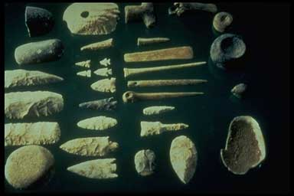

**Document 2**: The following document is discussing the papyrus plant most famously used in Ancient Egypt.

|  |
| --- |
| Papyrus plants are native to river banks and marshy areas as they consume great quantities of water. Water and nutrients are carried from the roots, via a system of longitudinal fibrovascular bundles, up a thick and tapering triangular stalk that measures around 5–8 centimeters in diameter at its base to the wide flower head, or umbrel, at a height of around 4 meters (or 13 feet). The tough green rind of the papyrus stalk encloses the white pith, from which the papyrus sheet is made. The pith is composed of the rigid ligneous and cellulosic fibrovascular bundles, and empty parenchyma cells with cellulose and hemi-cellulose walls, which function as air passages and give buoyancy to the stalk.  The text of a papyrus was written by a scribe in black and red ink. The black ink contains a carbon-based pigment, made either from incinerated vegetable material or from soot. The red ink tends to be either red iron-oxide (anhydrous oxide of iron) or red ocher (hydrated oxide of iron). The painter’s palette, which he employed in painting the illustrations on the papyrus, can include several colors. |

**Document 3**: The following is a document discussing Greek architecture.

Greek architects created the three “orders,” or styles, of columns. Those three, depicted in the image below are the Doric, Ionic, and Corinthian orders. These styles are still common on many modern buildings especially museums, libraries, and government buildings.

